DEFINITION- WHAT IT MEANS:
A canoe is a small, narrow boat that you padde through the water using a stick with a wide end called a paddle.
NOUN – Example sentence- We travelled down the river in a wooden canoe.
Learning new vocabulary (words) and remembering them!
USE WORD HIPPO FOR DEFINITIONS/ PRONUNCIATION-HOW YOU SAY THE WORD.
https://www.wordhippo.com OR https://www.collinsdictionary.com
STARTS WITH - c
SYLLABLES – 2 - ca-noe
I remember going canoeing when I was 12 on a beautiful, sunny day.

Any memories/ ideas linking to this word?

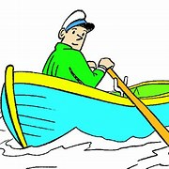
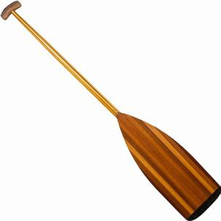

ASSOCIATED WORDS
paddle

row
float

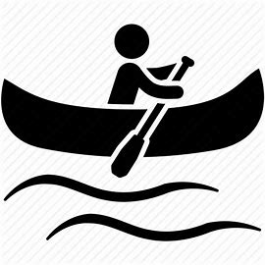
SYMBOL
Make up an action/ mime-
with or without props!
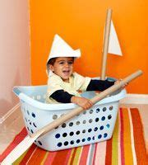
Write the word out using bubble writing and patterns/ pictures.
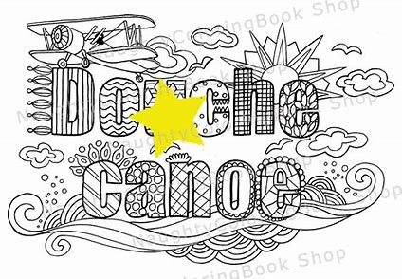
DINGY
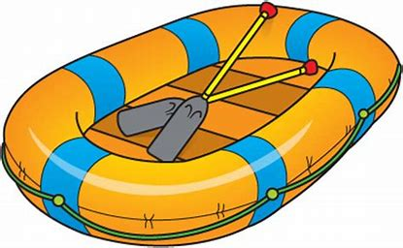
GONDOLA
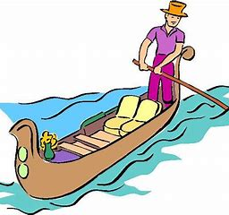
KAYAK
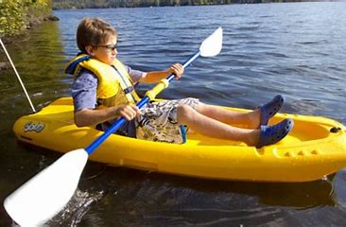
SYNONYMS (SIMILAR WORDS)

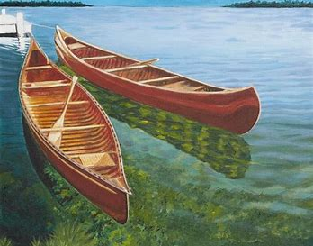
PLURAL:
CANOES
Other uses- can also be a verb. (To) canoe
He canoed down the river.
I went canoeing at the weekend.
canoe
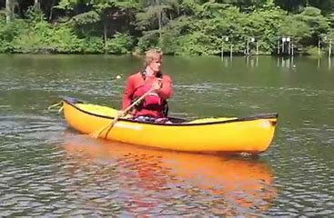
PICTURE
Rhymes with...
And spelt with the same ending:
SHOE
Other words that rhyme:
BLUE
GLUE
CLUE
DO
ZOO
THREW
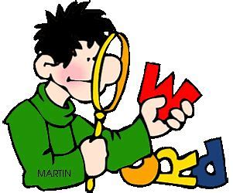

Look for parts of the word you can read/spell.
HIGHLIGHT THEM

