Spelling strategies.  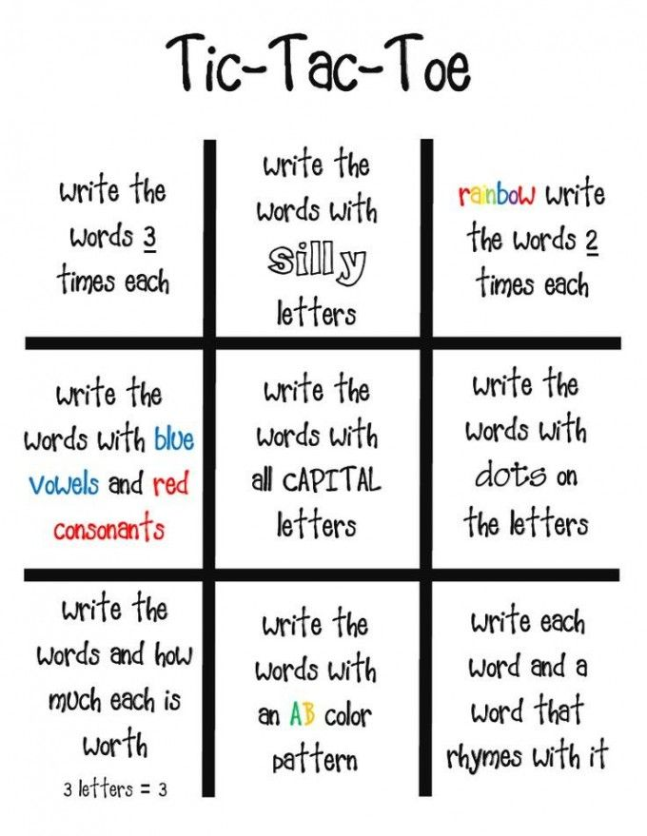 | 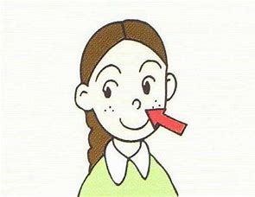  Spell the word in the air with different body parts e.g. elbow, nose or toe. Repeat with eyes shut. | Make words out of plasticine…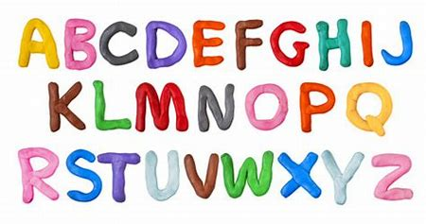  Trace over letter with your finger. | Or tin foil!  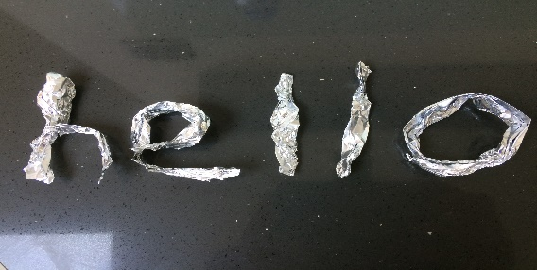
Make a mnemonic  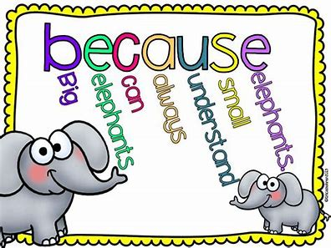  necessary  Never eat crisps eat salad sandwiches and remain young. | Take it in turns to say each letter of a word while throwing or kicking a ball to each other.   | Write it outside with chalk or sticks/ other natural objects.  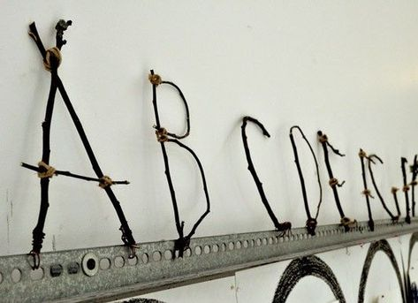 | Write it in rice or cous-cous on a tray.  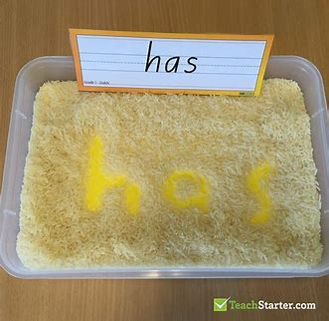  Shaving foam
How many times can you write the word in a minute?   | How small can you write the word?  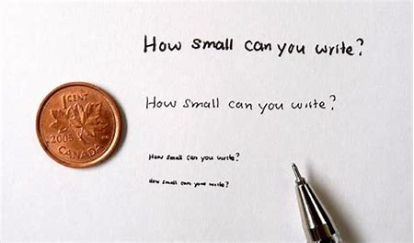  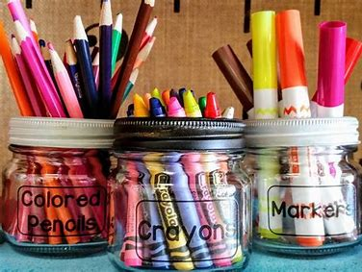 | Write using a wide variety of pens, pencils, paints and crayons. The different pressure required to hold different writing tools makes it a more multi-sensory experience and therefore more memorable! | 