Write the word out using bubble writing and patterns/ pictures.
DEFINITION- WHAT IT MEANS:

Word class:
Learning new vocabulary (words) and remembering them!
USE WORD HIPPO FOR DEFINITIONS/ PRONUNCIATION-HOW YOU SAY THE WORD.
https://www.wordhippo.com OR https://www.collinsdictionary.com
STARTS WITH -
SYLLABLES –

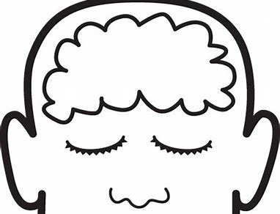
Any memories/ ideas linking to this word?

SYMBOL
Make up an action/ mime-
with or without props!

SYNONYMS (SIMILAR WORDS)

PLURAL:

Other uses:

PICTURE
Rhymes with...
And spelt with the same ending:

Other words that rhyme:
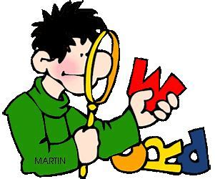

Look for parts of the word you can read/spell.
HIGHLIGHT THEM

