How to learn the word | Egyptian words you need to know
Use mnemonics – this is making up a saying, so you remember the first letter of each word.  One you already know:  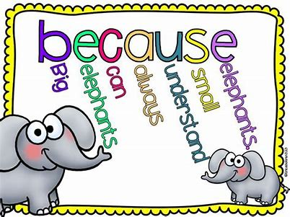 | Egypt  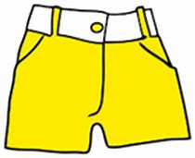  yellow  pants  today.    gets  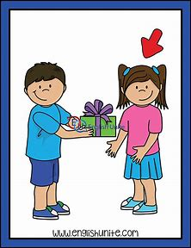  Everyone  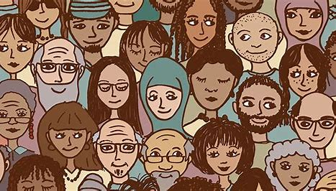
Count the syllables (breaking the word into parts). Clap the syllables- try banana and watermelon. Try your name.  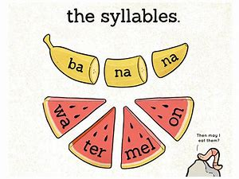 | papyrus pa/py/rus  Papyrus is made from the Papyrus plant: long ago, people used to write on it.  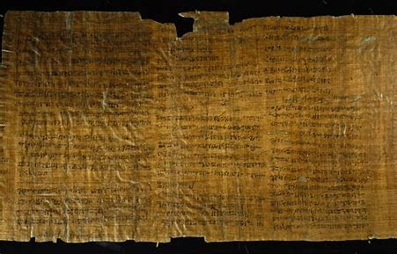
Highlight tricky parts of the word in colour.  Pharaoh | Draw a picture or symbol of the word: this helps your brain to remember the word!  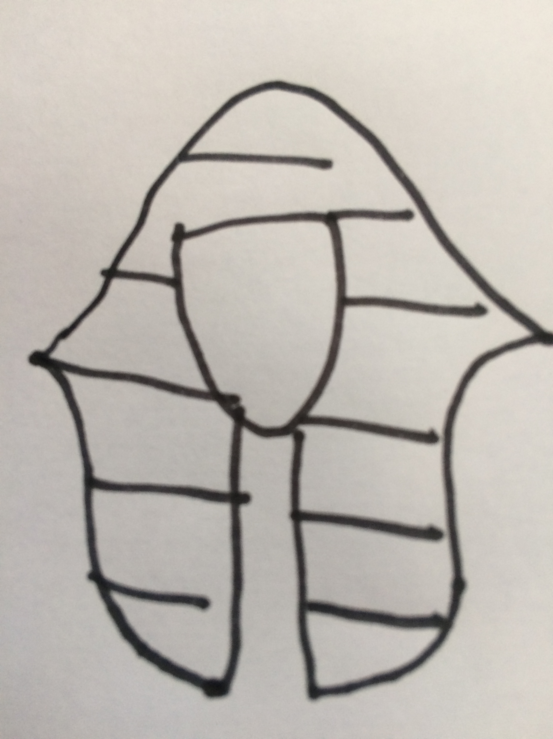  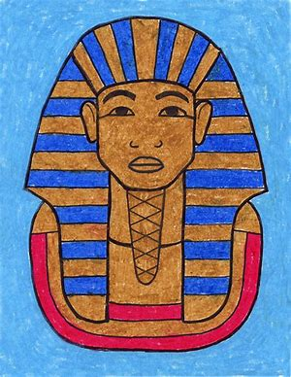
Use lots of different pens, pencils, paints; chalk (outside); anything you can find to write with!  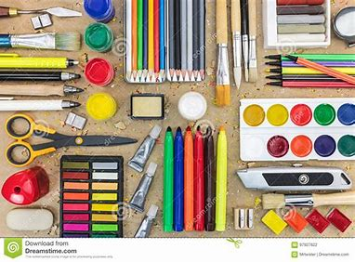 | 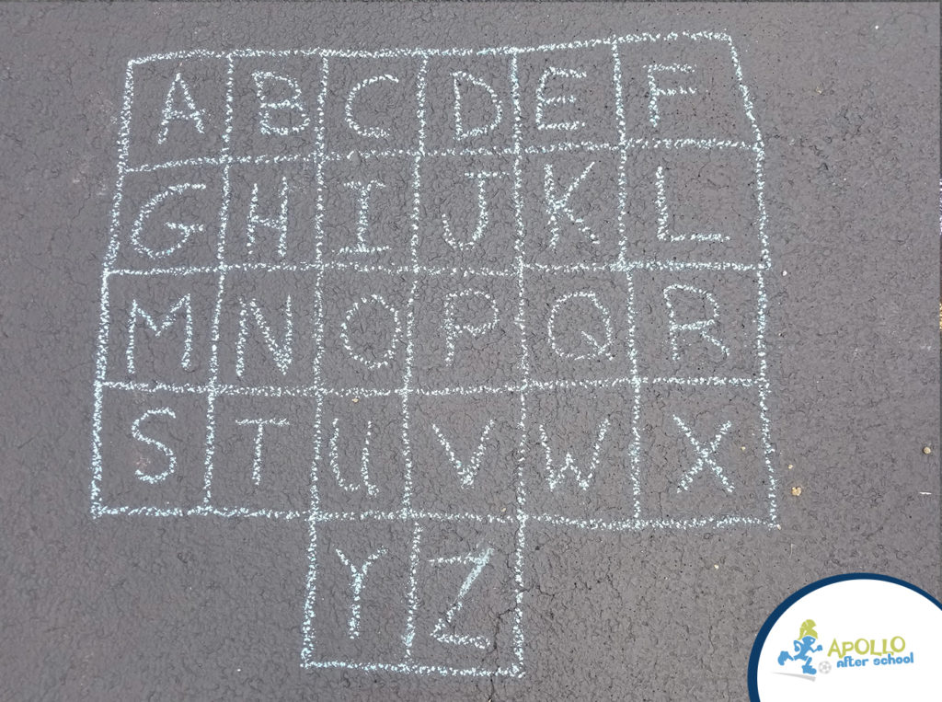  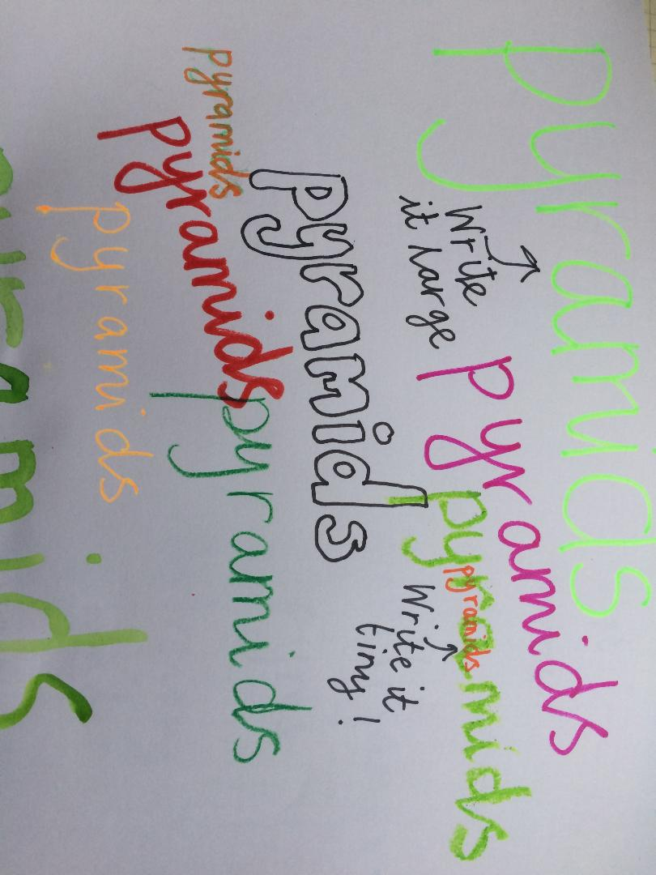  Write the letters of the alphabet in chalk. Jump or hop to the letters in the word you are learning, while saying the letters aloud to yourself. When you feel confident you know the spelling, write it in chalk underneath.

