PRECISE NOUNS
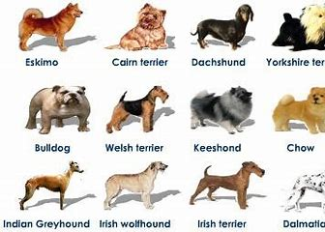
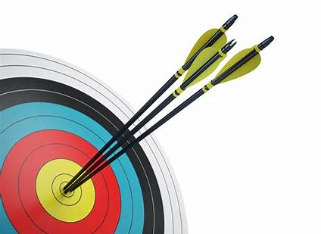
Precise means to be exact or completely clear.
Precise nouns help the reader gain a clearer, brighter picture in their head.
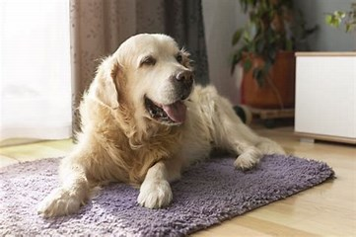
For example:
The dog sat on the floor.
The Labrador sat on the rug.
The nouns are in red. To improve the picture in the reader’s mind, as writers we need to give more detail and one way of doing this is to use precise nouns. In the example we have chosen Labrador as the type of dog and improved floor with rug. Here is another example:
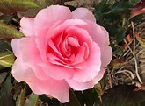
The flower smelt lovely.
The rose smelt lovely.
Choose a ‘topic’ for example, flowers, trees, shoes, hairstyles, buildings…it could be anything! And make a mind map of precise nouns. You can draw, collage, paint, make on the computer. See my example below:
COW PARSLEY
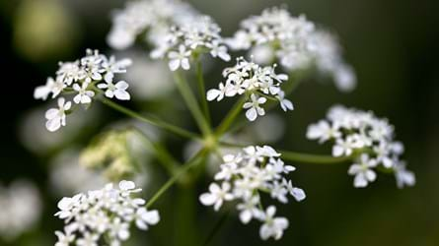
BLUEBELL
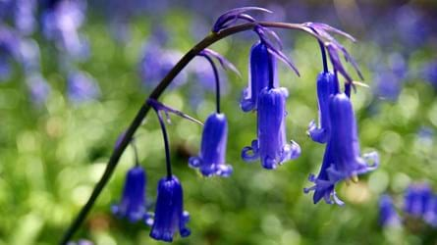

tulip
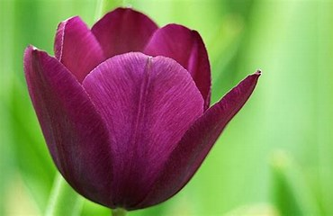

SPRING FLOWERS
USING MIND-MAPS, PICTURES AND DIFFERENT COLOURS IS A GREAT WAY TO PLAN AND REMEMBER THINGS.
ORCHID
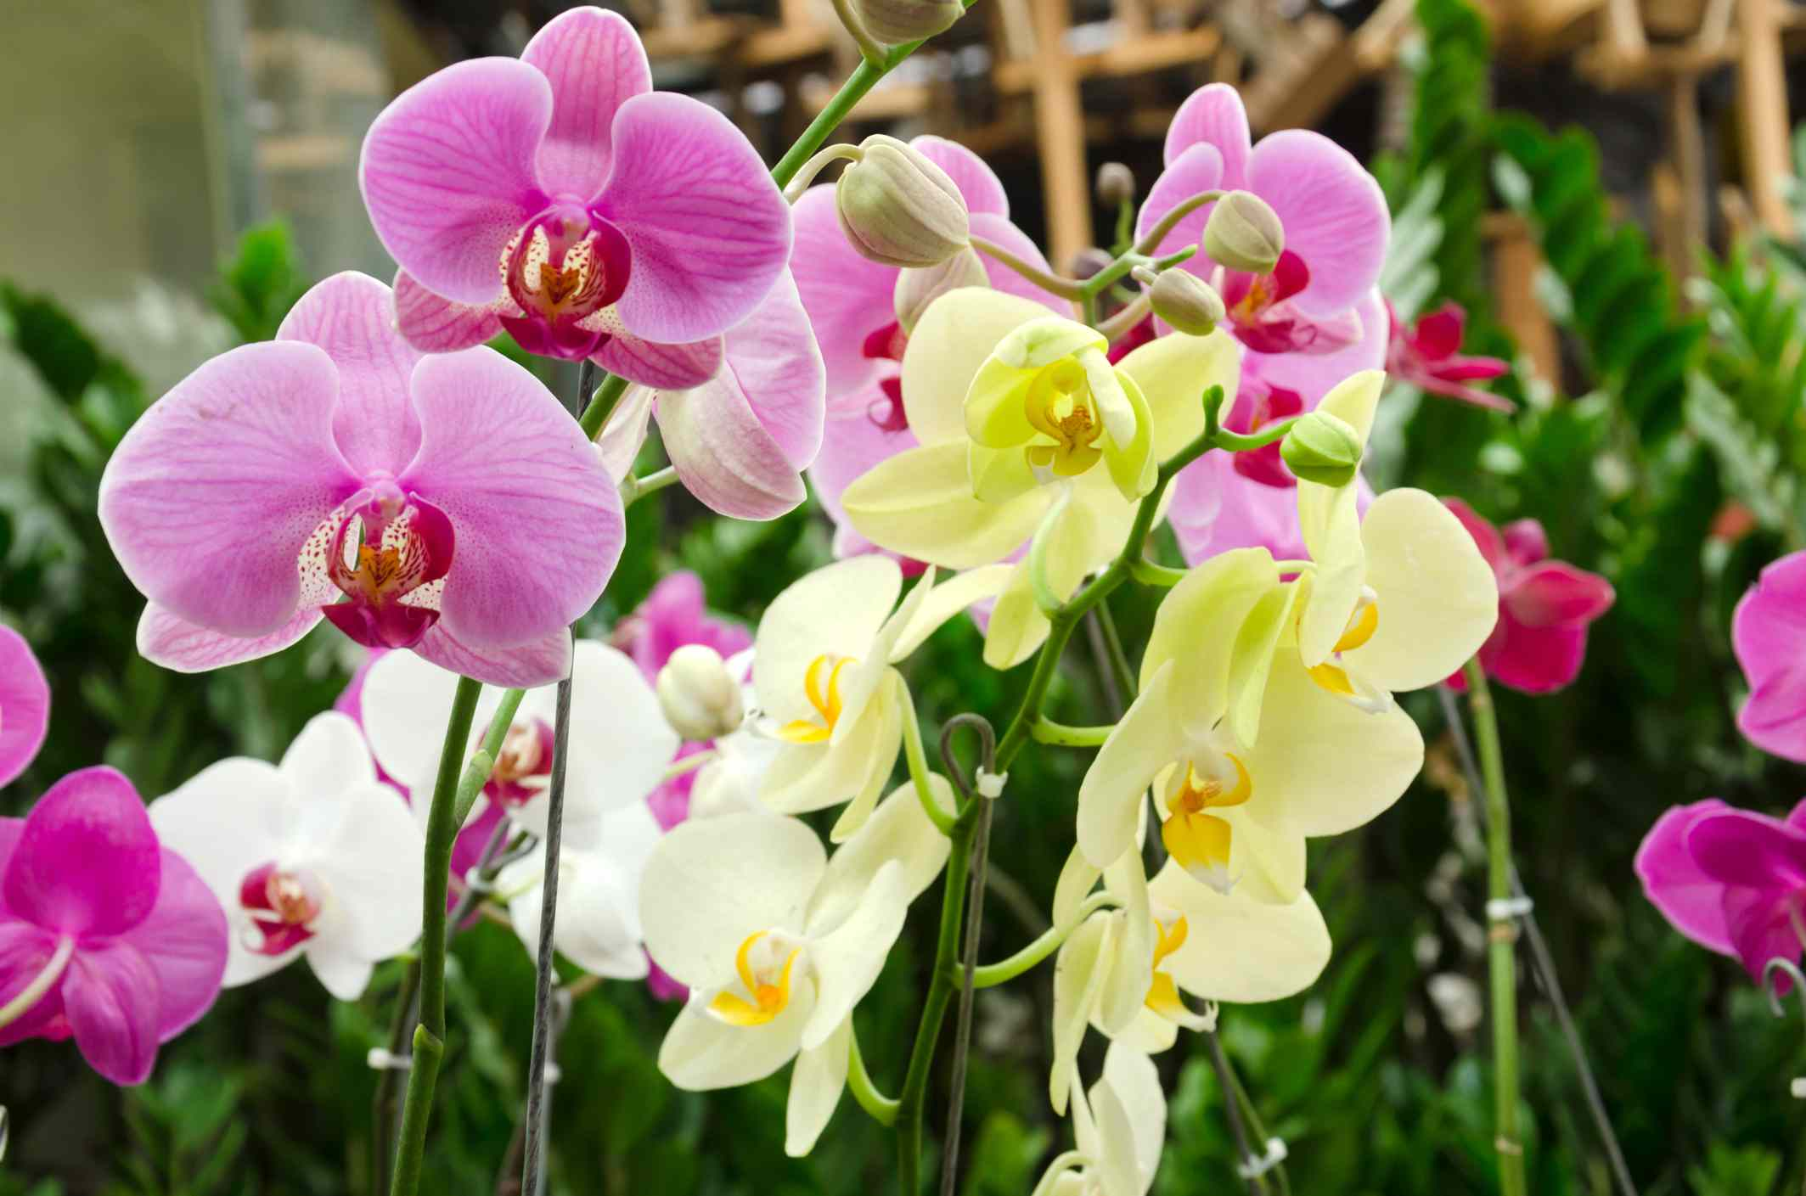
HIBISCUS
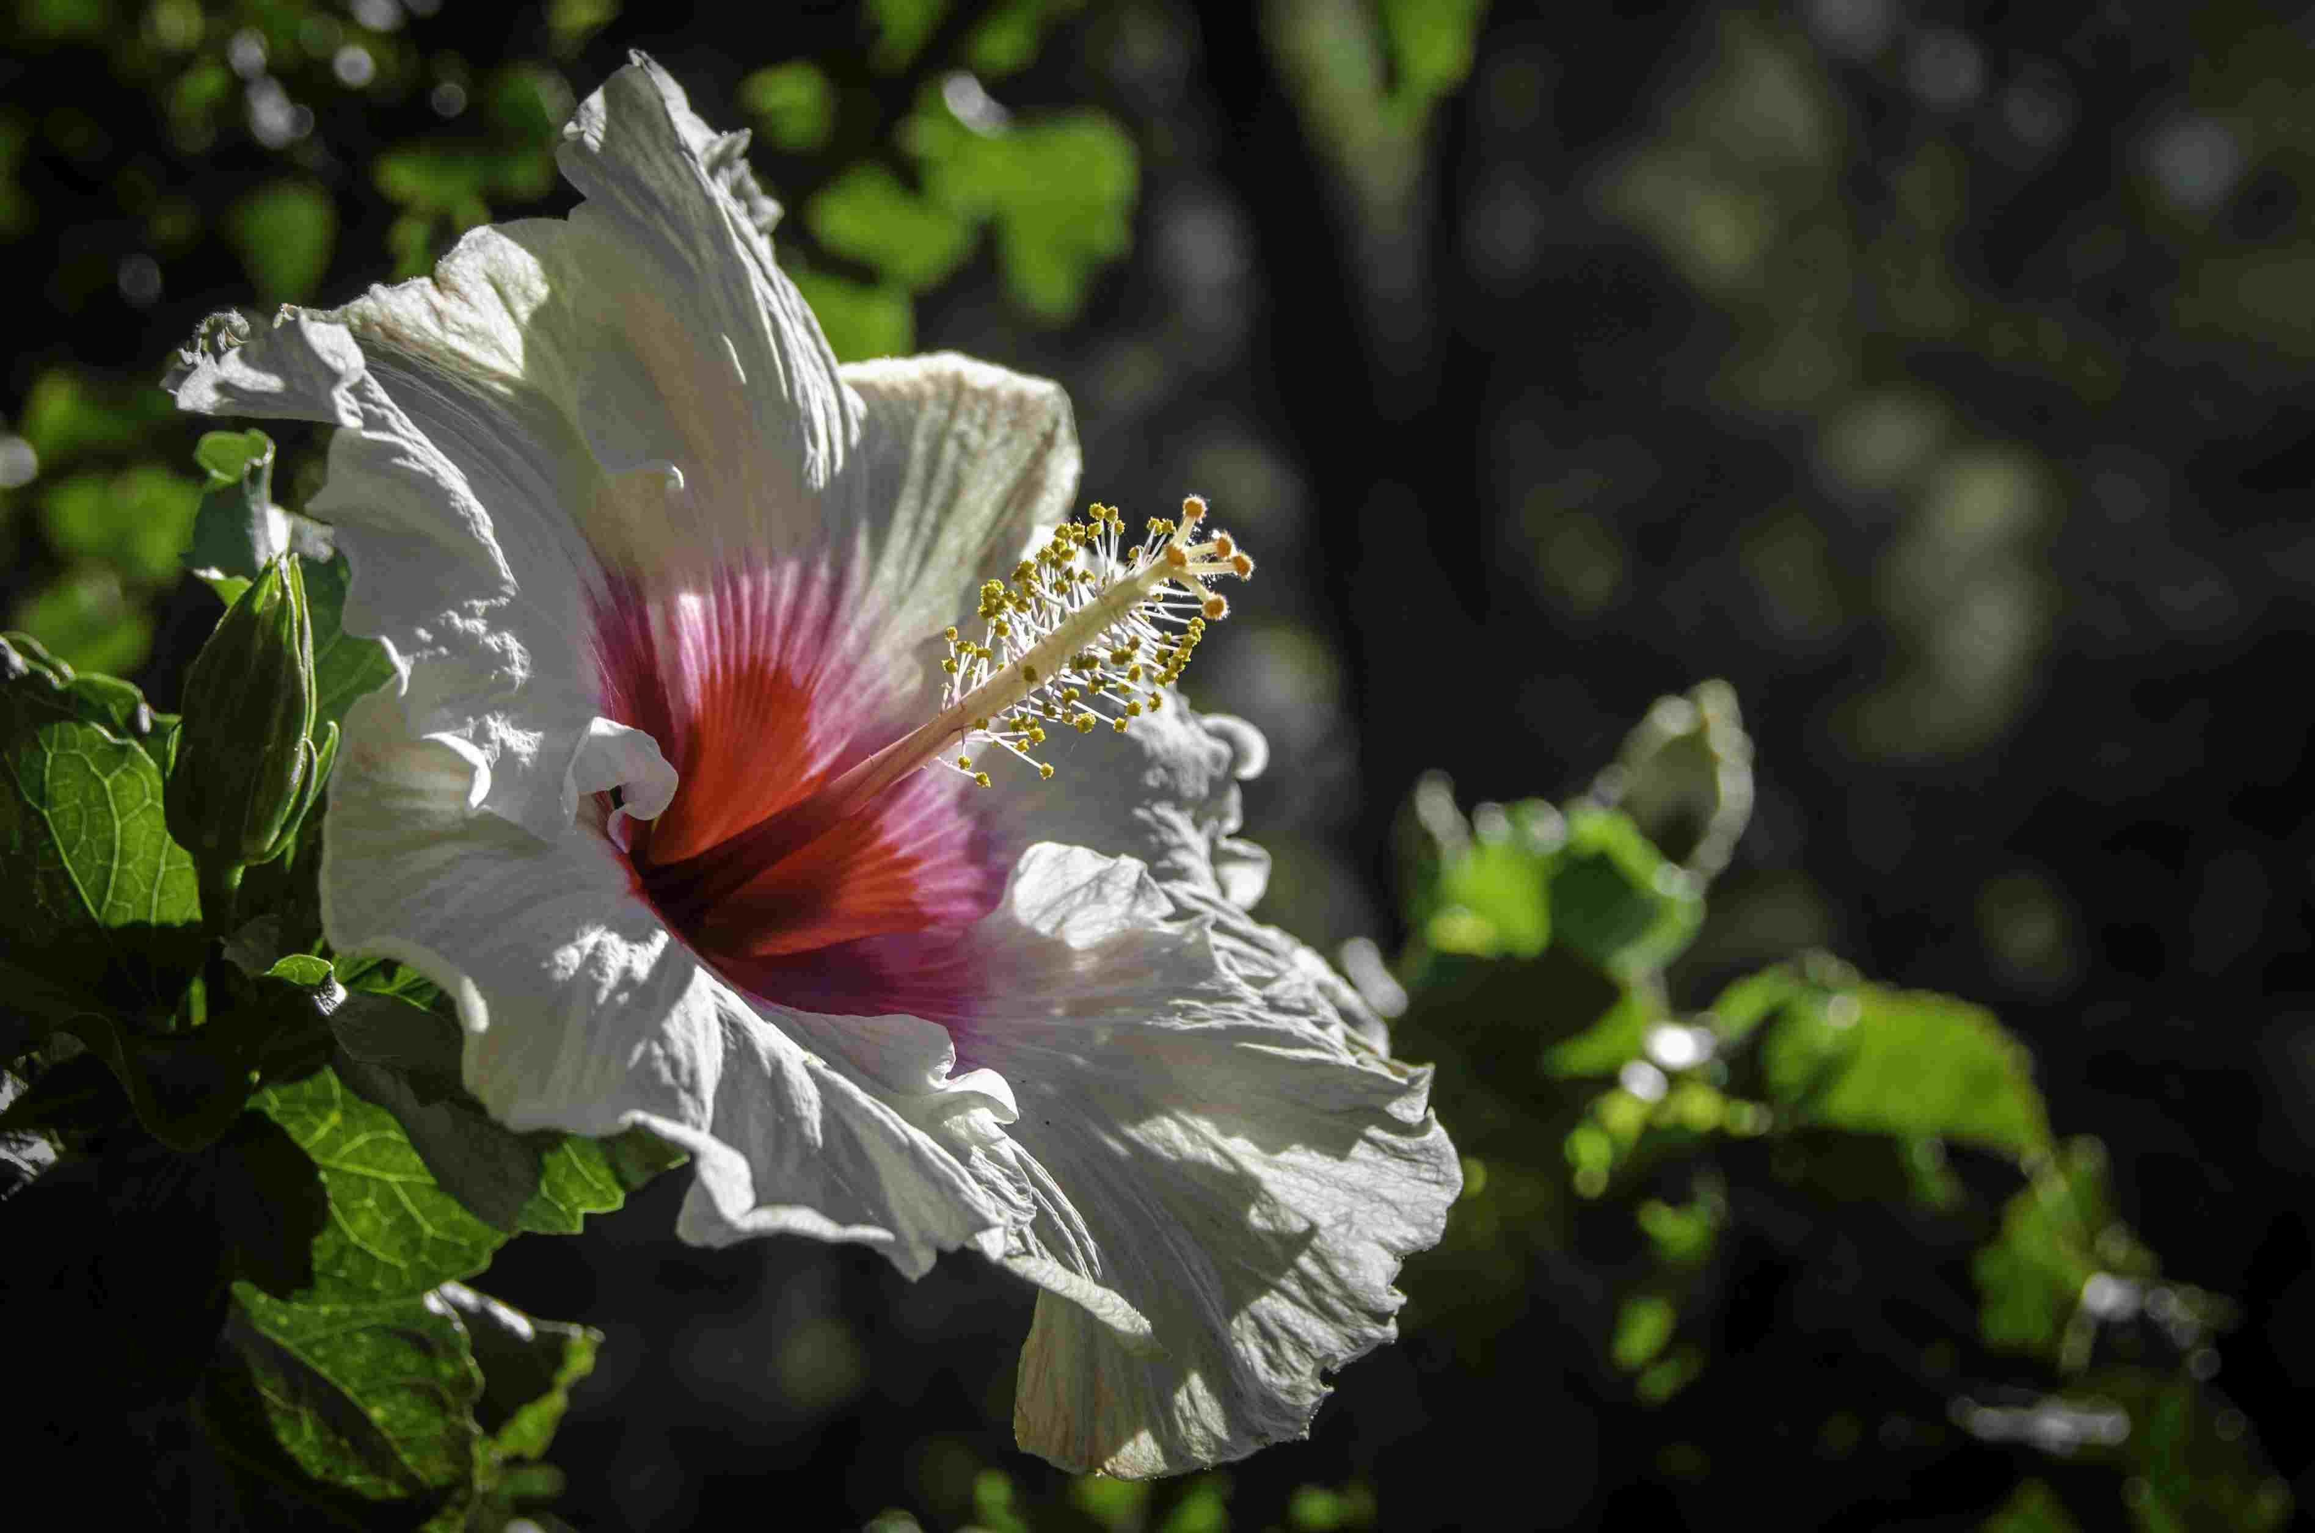
TROPICAL FLOWERS
FLOWER

COWSLIP
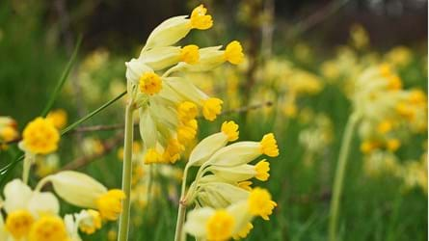
WOODLAND FLOWERS
Snowdrop
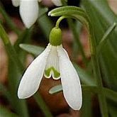
daffodil
